CSS Grid

Theory Assignment
Question 1: Explain CSS Grid and how it differs from Flexbox. When would you use Grid over Flexbox?
Ans: CSS Grid is a powerful layout system in CSS used to design two-dimensional layouts — meaning it can handle both rows and columns at the same time. You define a grid container, set up columns and rows, and then place items into the grid using line numbers or named areas.
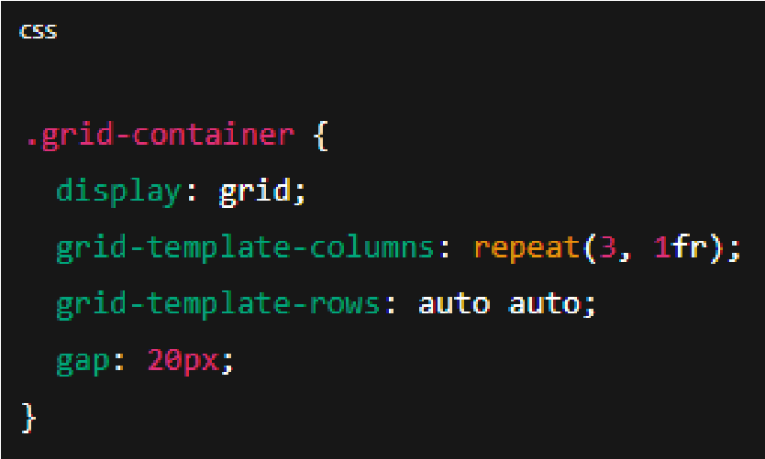

Flexbox is a one-dimensional layout model. You can lay out items either in a row (horizontal) or in a column (vertical) — but not both at the same time.

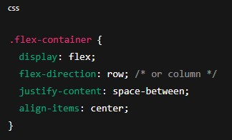

When to use Grid vs Flexbox:
Use CSS Grid when:
- You need to design a whole page or layout a complex component.
- You need precise control over rows and columns.
- You want to create asymmetric or overlapping layouts.
Use Flexbox when:
- You’re aligning items in a single row or column.
- You need to space elements evenly, like buttons or nav links.
- You want content to flow and wrap automatically.

Question 2: Describe the grid-template-columns, grid-template-rows, and grid- gap properties. Provide examples of how to use them.

Ans: Grid-template-column:
This property defines how wide each column in you grid should be.
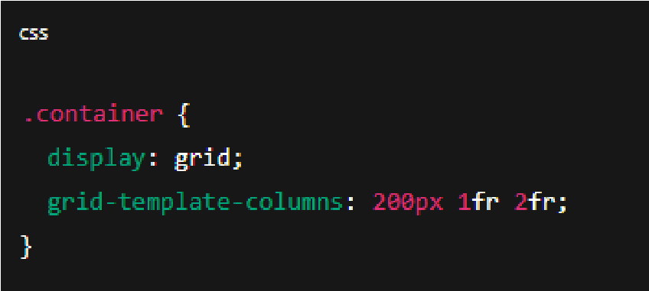
What it does:
- The first column is 200px wide.
- The second column takes up 1 fraction of the remaining space.
- The third column takes up 2 fractions, which means it’s twice as wide as the second column.

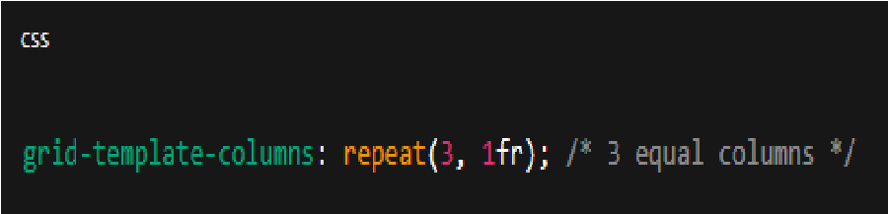
Grid-template-row:
This works just like grid-template-column, but for rows instead of column.
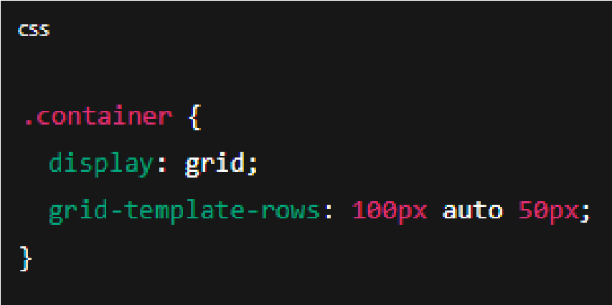

What it does:
- The first row is 100px tall.
- The second row automatically adjust to fits its content.
- The third row is 50px tall.

Grid-gap:
This property sets the space between rows and columns in a grid. It’s a shorthand for setting both row and column gaps at once. You can also set them separately with grid-row-gap and grid-column-gap.

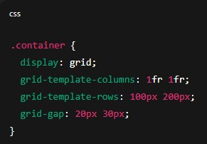
What it does:
- Two columns, each taking up 50% of the available space.
- Two rows, one 100px and the other 200px tall.
- A 20px gap between the rows and a 30px gap between the columns.

